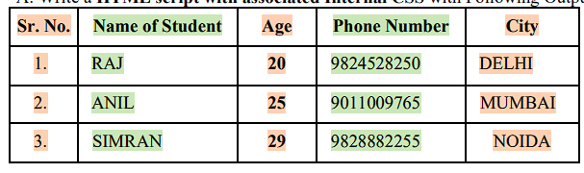
HTML Code
<!DOCTYPE html>
<html lang="en">
<head>
<meta charset="UTF-8">
<meta name="viewport" content="width=device-width, initial-scale=1.0">
<title>Student Information</title>
<style>
body {
font-family: Arial, sans-serif;
}
table {
width: 100%;
border-collapse: collapse;
}
th, td {
border: 1px solid black;
padding: 8px;
text-align: center;
}
th .highlight-salmon, td .highlight-salmon {
background-color: #FFA07A; /* Light Salmon */
}
th .highlight-green, td .highlight-green {
background-color: #90EE90; /* Light Green */
}
</style>
</head>
<body>
<div class="table-container">
<table>
<tr>
<th><span class="highlight-salmon">Sr. No.</span></th>
<th><span class="highlight-green">Name of Student</span></th>
<th><span class="highlight-salmon">Age</span></th>
<th><span class="highlight-green">Phone Number</span></th>
<th><span class="highlight-salmon">City</span></th>
</tr>
<tr>
<td><span class="highlight-salmon">1.</span></td>
<td><span class="highlight-green">RAJ</span></td>
<td><span class="highlight-salmon">20</span></td>
<td><span class="highlight-green">9824528250</span></td>
<td><span class="highlight-salmon">DELHI</span></td>
</tr>
<tr>
<td><span class="highlight-salmon">2.</span></td>
<td><span class="highlight-green">ANIL</span></td>
<td><span class="highlight-salmon">25</span></td>
<td><span class="highlight-green">9011009765</span></td>
<td><span class="highlight-salmon">MUMBAI</span></td>
</tr>
<tr>
<td><span class="highlight-salmon">3.</span></td>
<td><span class="highlight-green">SIMRAN</span></td>
<td><span class="highlight-salmon">29</span></td>
<td><span class="highlight-green">9828882259</span></td>
<td><span class="highlight-salmon">NOIDA</span></td>
</tr>
</table>
</div>
</body>
</html>

